JHipster with a Microservice Architecture

**1. Introduction**

In this writeup, I will explore an interesting example with [JHipster](https://jhipster.github.io/) – building a simple microservices architecture. I will show how to build and deploy all the required pieces, and in the end, we’ll have a full-blown microservice application up and running.

If you’re new to JHipster, please check [the introductory article](http://www.baeldung.com/jhipster) before proceeding to have a good understanding of the basics of this project generation tool.

**2. Microservice**

The microservice system will separate the front-end the back-end which, in turn, can also be split into several small applications, each dealing with a subset of the full application domain. Naturally, as with all microservice implementations, this solves some problems but also introduces some complexity, such as dealing with component registry and security.

JHipster will take care of most difficulties of managing the microservice applications, with the help of modern open-source tools like Netflix’s [Eureka Server](https://github.com/Netflix/eureka/) and Hashicorp’s [Consul](https://www.hashicorp.com/blog/consul-announcement/).

There are, of course, some things to consider here, like how big or complicated our domain is, how critical is our application and what levels of availability do we want need to have, are we going to host our services on different servers and locations, etc. The goal of these tools is of course to these permutations possible and easy to manage.

**2.1. JHipster Microservice Components**

When working on a Microservice architecture with JHipster, we’ll need to build and deploy at least three different projects: a JHipster Registry, a Microservice Gateway, and at least one Microservice Application.

**The JHipster Registry** is an essential piece of the microservice architecture. It ties all the other components together and enables them to communicate with each other.

**The Microservice Application** contains the back-end code. Once running it will expose the API for the domain it is concerned with. A Microservice Architecture may be composed of many microservice applications, each containing a few related entities and business rules.

**And the Microservice Gateway** has all the front-end (Angular) code and will consume the API created by the whole group of micro service applications:

[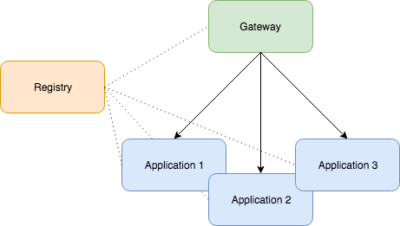](http://www.baeldung.com/wp-content/uploads/2017/05/JHipster-Microservice-Architecture.png)

**3. Installation**

For JHipster you need to install the following:

Install JDK 8

Install git

Install node

Install yarn

Install yeoman  - npm install -g yo

Install Jhipster - npm install -g generator-jhipster

Or for all the details about the installation process, check the [introductory article on JHipster](http://www.baeldung.com/jhipster).

**4. Creating a Microservice Project**

Now let’s install the three core components of our microservice project.

**4.1. Installing JHipster Registry**

Since the JHipster Registry is a standard JHipster, so we just need to download and run it. There is no need to modify it:

|  |  |
| --- | --- |
| 1  2 | git clone https://github.com/jhipster/jhipster-registry  cd jhipster-registry && **./mvnw** |

This will clone the *jhipster-registry* project from GitHub and start the backend application.

For starting the frontend of this JHipster-registry you open up a second terminal and go to the same folder of jhipster-registry.

And start the frontend with:

* yarn
* yarn start

Once it successfully starts up, we can visit <http://localhost:9000/#/>

and log in with user *admin* and password *admin*:



**4.2. Installing a Microservice Application**

Here is where we start to build the actual features of our project. In this example, we’ll create a simple Microservice Application that manages cars. So first we’ll create the application, and then we’ll add an entity to it:

|  |  |
| --- | --- |
| 1  2  3  4 | Open a new Terminal:  # create a directory for the app and cd to it  mkdir car-app && cd car-app  # run the jhipster wizard  yo jhipsterx |
|  |  |

Once the wizard starts, let’s follow the instructions to create a Microservice type application named *carapp*. Some other relevant parameters are:

* port: 8081
* package: *com.car.app*
* authentication: JWT
* service discovery: JHipster Registry

The screenshot bellow shows the complete set of options:

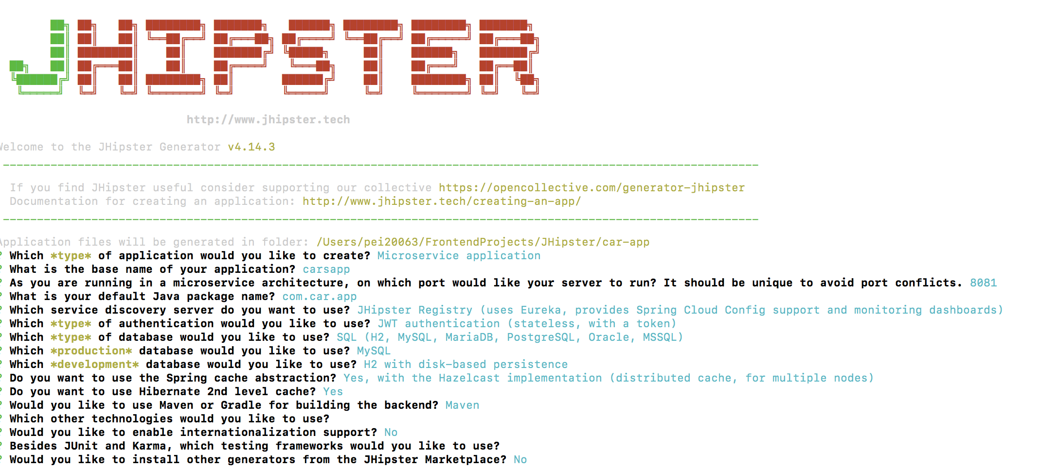

Now we’ll add a *car* entity to our application:

|  |  |
| --- | --- |
| 1  2 | # runs entity creation wizard  yo jhipster:entity car |

The entity creation wizard will start. We should follow the instructions to create an entity named the *car*with three fields: *make*, *model*, and *price.*

Once that’s finished, our first Microservice application is complete. If we have a look at the generated code, we’ll notice that there’s no javascript, HTML, CSS or any front-end code. Those will all be produced once the Microservice Gateway is created. Also, check out the README file for important information about the project and useful commands.

To finish up, let’s run our newly created component:

|  |  |
| --- | --- |
| 1 | ./mvnw |

Before running the above command, we should ensure that the *jhipster-registry* component is up and running. Otherwise, we’ll get an error.

If everything went according to plan, our *car-app* would start, and the *jhipster-registry* log will tell us that the app was successfully registered:

|  |  |
| --- | --- |
| 1  2 | Registered instance CARAPP/carapp:746e7525dffa737747dcdcee55ab43f8    with status UP (replication=true) |

**4.3. Installing a Microservice Gateway**

Now the front-end bit. We’ll create a Microservice Gateway and indicate to it that we have an entity on an existent component for which we want to create the front-end code:

|  |  |
| --- | --- |
| 1  2  3  4 | Open a new Terminal:  # Create a directory for our gateway app  mkdir gateway-app && cd gateway-app  # Runs the JHipster wizard  yo jhipster |

Let’s follow the instructions to create an application of type Microservice: **gateway**. We’ll name the application *gateway*, and select the following options for the other parameters:

* port: 8080
* package: *com.gateway*
* auth: JWT
* service discovery: JHipster Registry

Here is a summary of the complete set of parameters:

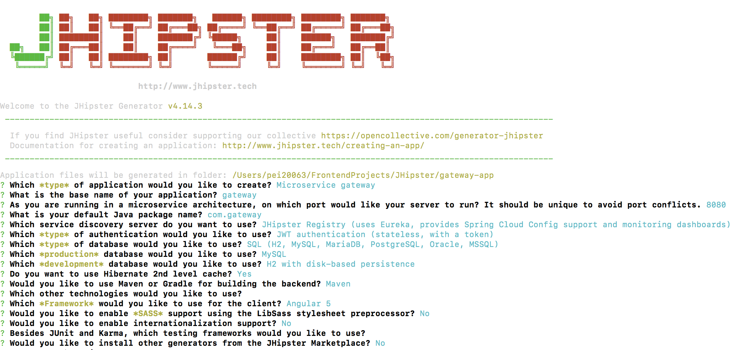

Let’s move on to entity creation:

Open a new Terminal:

|  |  |
| --- | --- |
| 1  2 | # Runs entity creation wizard  yo jhipster:entity car |

When asked if we want to generate from an **existent microservice**, choose ***Yes****,*then type in the relative path to the *car-app* root directory (ex.: **../car-app**). Finally, when asked if we want to update the entity, choose *Yes, regenerate the entity*.

JHipster will find the *Car.json* file which is part of the existent Microservice Application we’ve created earlier and will use the metadata contained in that file to create all the necessary UI code for that entity:

|  |  |
| --- | --- |
| 1 | Found the .jhipster/Car.json configuration file, entity can be automatically generated! |

Time to run the *gateway-app* and test if everything is working:

|  |  |
| --- | --- |
| 1  2 | # Starts up the gateway-app component  ./mvnw |

Let’s now navigate to http://localhost:8080/ and log in with user *admin*and password*admin*. On the top menu, we should see an item *Car* that will take us to the car list page. All good!

[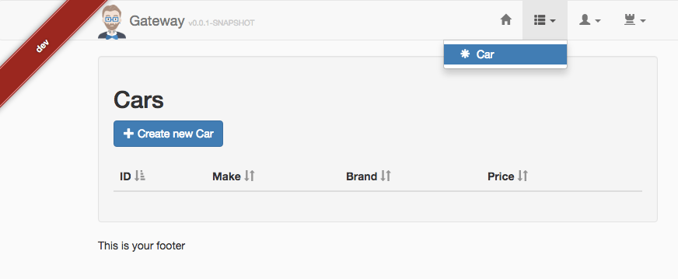](http://www.baeldung.com/wp-content/uploads/2017/05/jhipster-car-page.png) [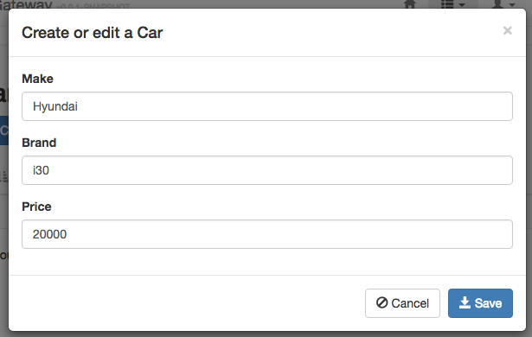](http://www.baeldung.com/wp-content/uploads/2017/05/jhipster-create-car.png)

**4.4. Creating a Second Microservice Application**

Next, let’s take our system one step further and **create a second component of type Microservice Application**. This new component will manage car dealers, so we’ll add an entity called the *dealer* to it.

Let’s create a new directory, navigate to it and run the *yo jhipster* command:

|  |  |
| --- | --- |
|  | 1. Open a new Terminal: 2. mkdir dealer-app && cd dealer-app 3. yo jhipster |

After that, we type in *dealerapp* as the application’s name and choose port ***8082***for it to run (it is critical that this is a different port than the ones we’re using for the *jhipster-registry* and *car-app*).

For the other parameters, we can choose any option we want. Remember this is a separate microservice so that it can use different database types, cache strategy, and tests than the *car-app* component.

Let’s add a couple of fields to our *dealer* entity. For example *name* and *address:*

|  |  |
| --- | --- |
| 1  2 | # Runs the create entity wizard  yo jhipster:entity dealer |

We shouldn’t forget to navigate to *gateway-app* and tell it to generate the front-end code for the *dealer* entity:

|  |  |
| --- | --- |
| 1  2  3  4 | # Navigate to the gateway-app root directory  cd ../gateway-app  # Runs the create entity wizard  yo jhipster:entity dealer |

Finally, run *./mvnw*on the *dealer-app* root directory to start up that component.

Next, we can visit our gateway application at http://localhost:8080 and refresh the page to see the newly created menu item for the Dealer entity.

Before we wrap up, let’s have a look at the *jhipster-registry* application again at http://localhost:8761/. Click on the Applications menu item to check that all of our three components were successfully identified and registered:  




That’s it! We’ve created a sophisticated architecture comprised of one Gateway app with all the front-end code backed by two microservices in just a few minutes.

**5. Conclusion**

Starting a Microservice Architecture project with JHipster is quite easy; we only need to create as many Microservice Applications as we need and one Microservice Gateway and we are ready to go.

You can explore the framework further over at the [official JHipster website](https://jhipster.github.io/microservices-architecture/).

As always, the codebase for our car-app, dealer-app, and gateway-app are available [over on GitHub](https://github.com/eugenp/tutorials/tree/master/jhipster/jhipster-microservice).